TERRAFORM CHALLENGE-02
Goal of the Exercise
The goal of this exercise is to test your understanding of a Cloud Compute deployment with
Terraform.
You are tasked with creating a codebase for a microservice deployment on a cloud
environment, using Terraform. Since our focus is not the application itself, the service will
be a simple web server that returns a static page.
Requirements
Service Details
The service will be a simple web server that returns a static page.
You can useapache2ornginxto serve a simple HTML file.
The service should becontainerizedand stored in aDocker registry.
The service should be deployed on asingle VM instanceas a docker container.
The image should be pulled from the registry specified earlier.
The service shouldnotbe accessible from the internet but only through aLoad
Balancer, except for SSH access from specific IP addresses.
Deliverables
You are to provide the following as part of your solution:
1. Dockerfileto build the image.
2. Terraform codebaseto deploy the following:
o Docker registry
o VPC and all required networking resources
o EC2 instance
o Load Balancer
Notes
Since a CI/CD pipeline is not part of this exercise, we will work around that with the
help of Terraform.
To push the image to the Docker registry,build the image locallybefore running the
Terraform code.
Once the image registry is created, use Terraform topush the local imageto the
registry.
Similarly, use Terraform topull the imagefrom the registry and run it on the VM
instance once it is created.
-- For SSH access:
o Use a locally created key.
o Add it to the cloud provider key storage.
o Attach it to the instance.
--UseTerraform best practicesfor file structure and code organization.
o Use variables, locals, modules, etc. when appropriate.
- Include alltfvars, scripts, and other helper files used to deploy the application.
- You may use any cloud provider of your choosing, althoughAWS is preferred.
- Use afree tier accountor atrial accountto deploy the resources.
------------------------------------------------------------------------------------------------------------------
Challenge Overview
This challenge demonstrates how to deploy a containerized web application on AWS using
Terraform. A simple Nginx web server was containerized using Docker and its image was
stored in Amazon ECR. Terraform was used to provision all the required AWS resources,
including the VPC, subnets, security groups, EC2 instance, IAM roles, and Application Load
Balancer.
The application is accessible only through the Load Balancer, while SSH access to the EC2
instance is restricted to a specific IP address. The entire deployment process is automated
using Infrastructure as Code principles, making it repeatable, secure, and easy to manage.
-First lets create project directory →inside it create one folder
--app
- Dockerfile
- Index.html
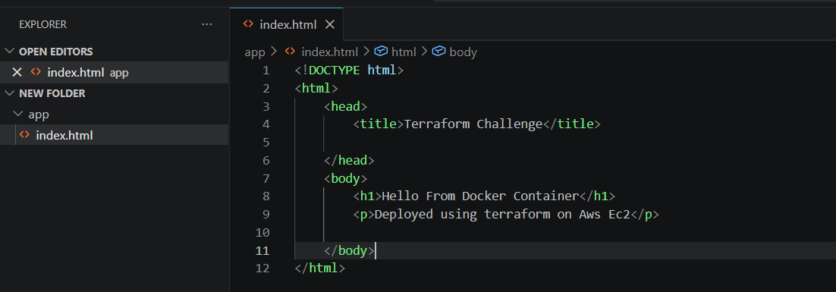
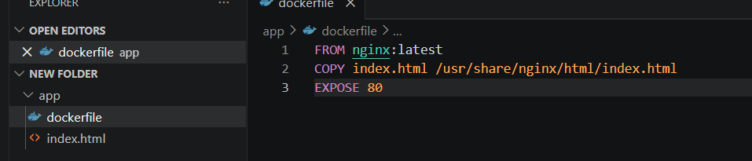
Lets build the image
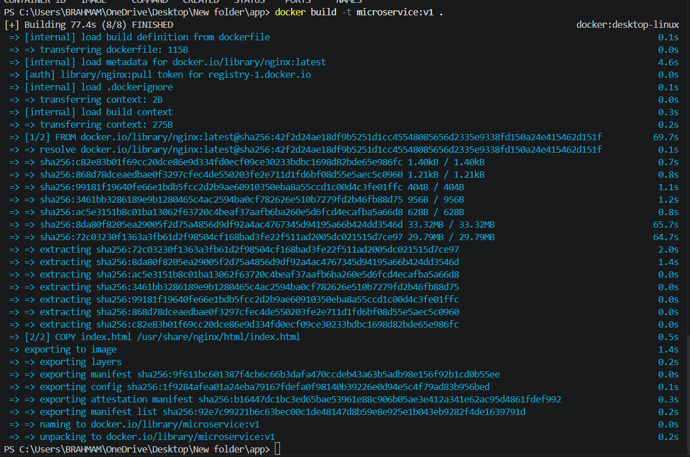
Open in the browser
http://localhost:8080
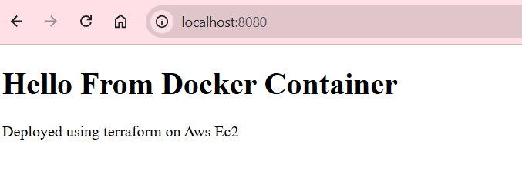
What was done:
- Created a Dockerfile using the official Nginx image.
- Replaced the default Nginx page with a custom index.html.
Amazon ECR (Elastic Container Registry)
Lets create main.tf
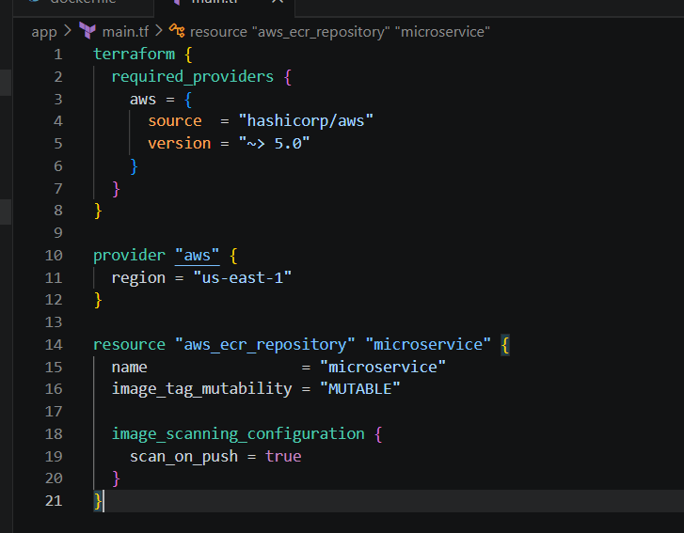
Terraform init
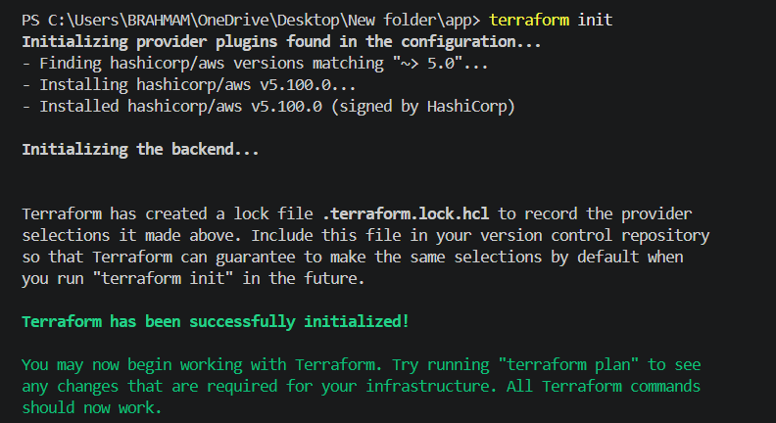
Terrafotm plan
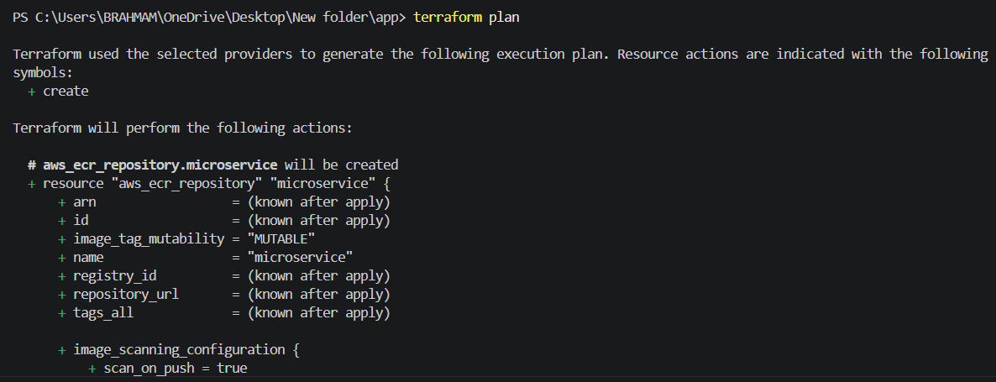
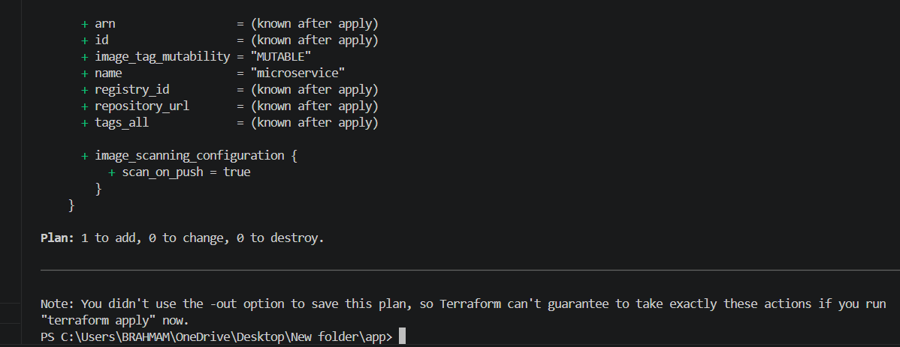
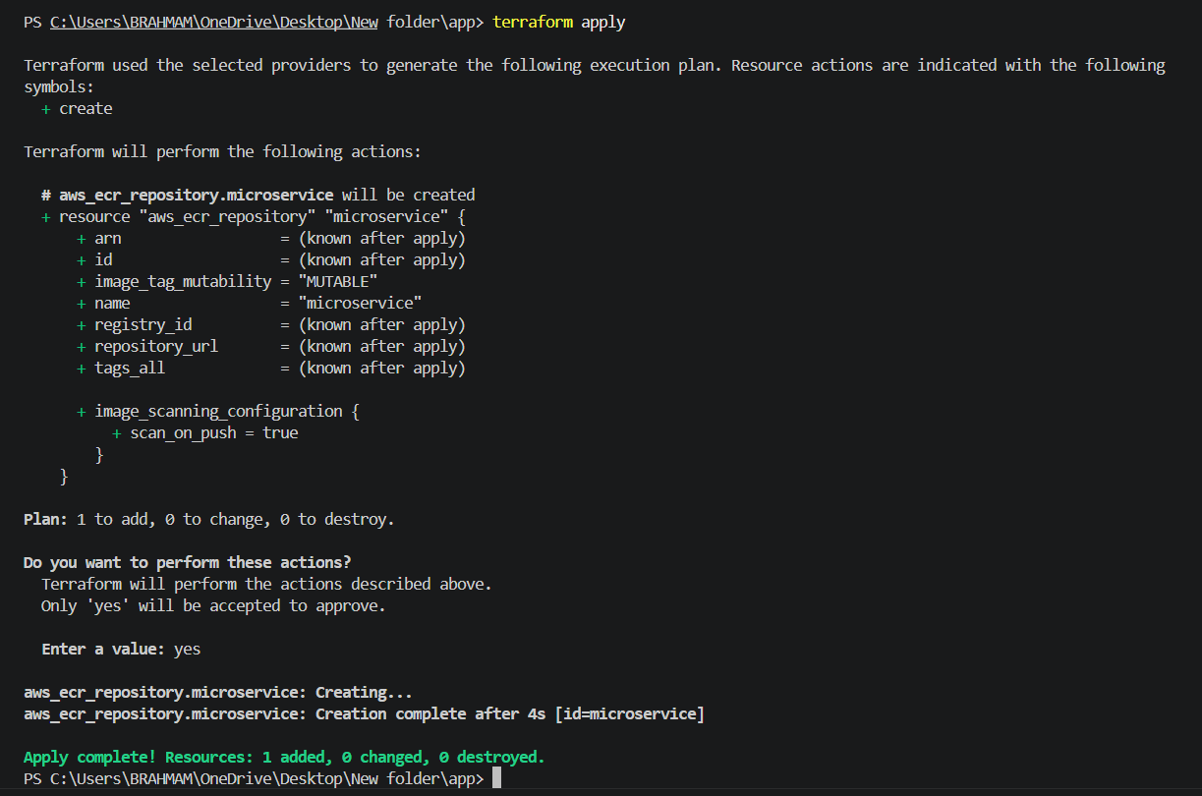
ECR created successfully
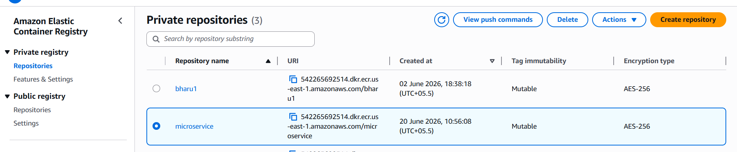
What was done:
- Created an ECR repository using Terraform.
- Built the Docker image locally.
- Tagged and pushed the image to ECR.
Why:
- ECR is AWS's managed Docker registry.
- Storing images in ECR allows EC2 instances to pull images securely.
- It eliminates the need for external registries such as Docker hub

create userdata.sh
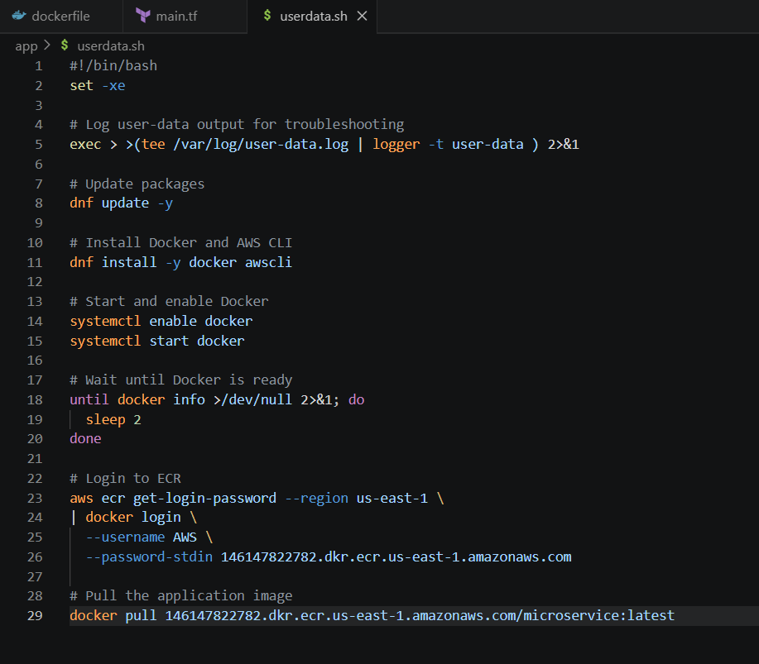
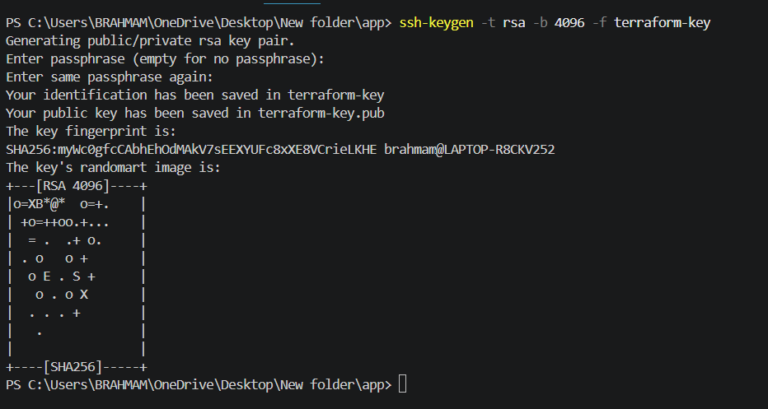
VPC and Networking
Create VPC
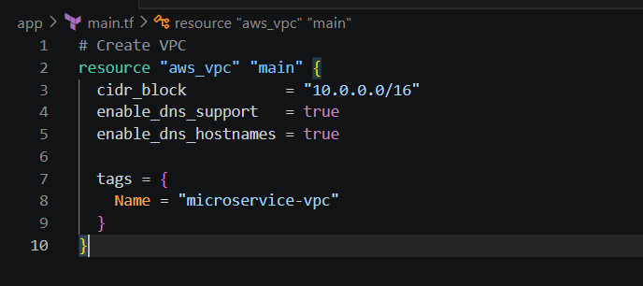
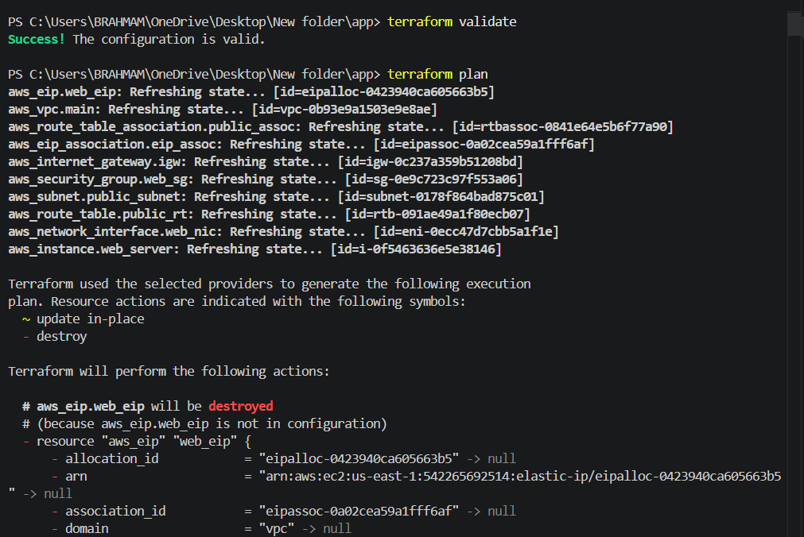

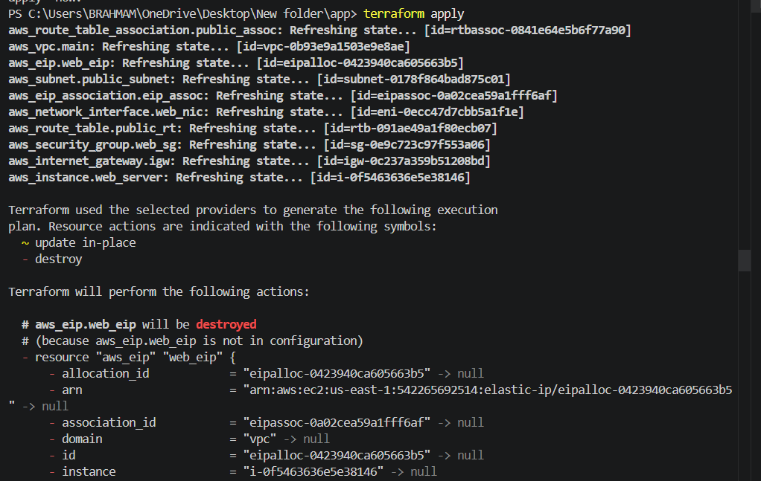
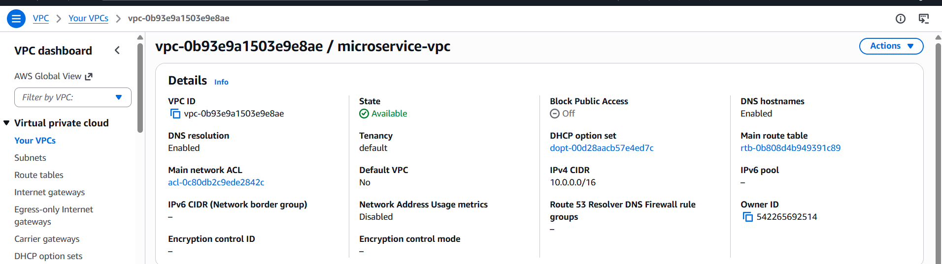
Create internet gateway
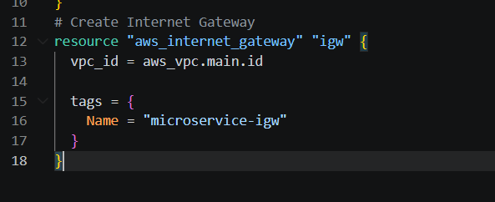
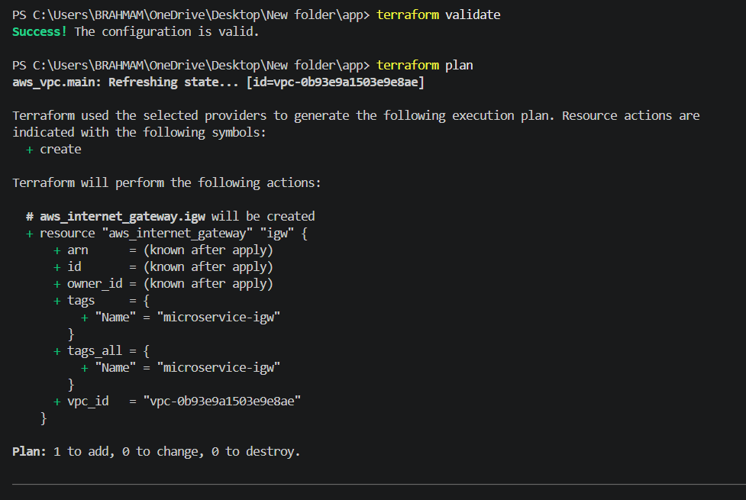
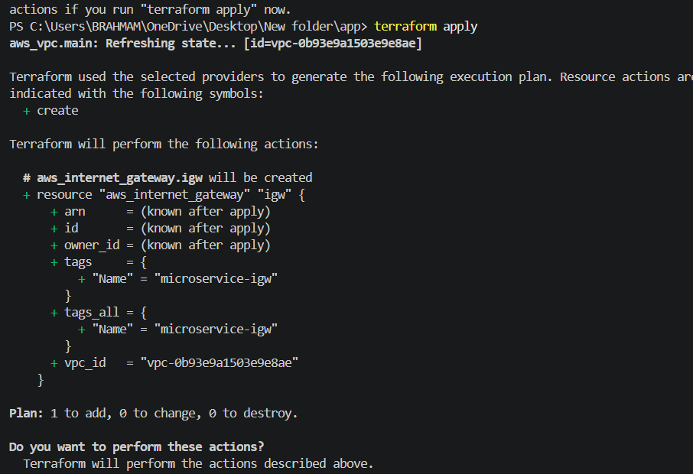
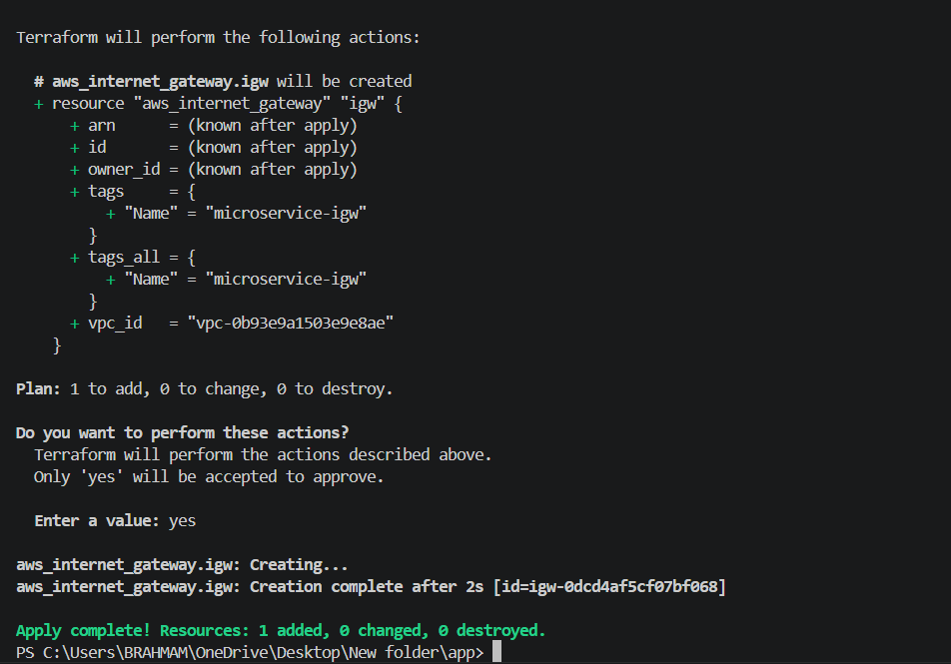
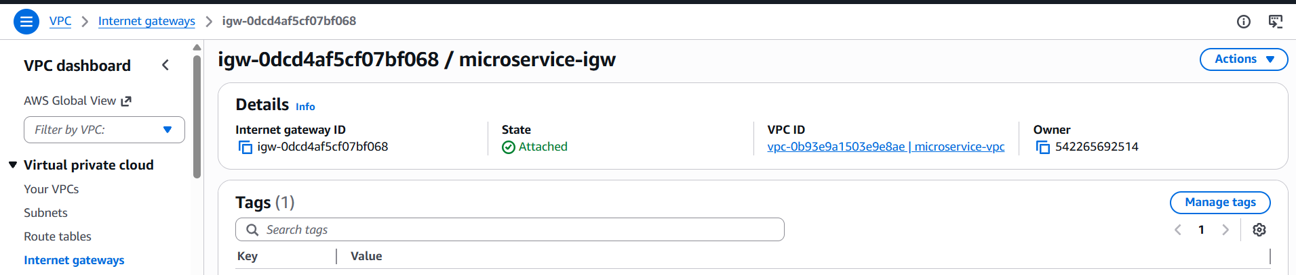
Create two subnets
AWS requires an Application Load Balancer (ALB) to be deployed in at least two Availability Zones (AZs).
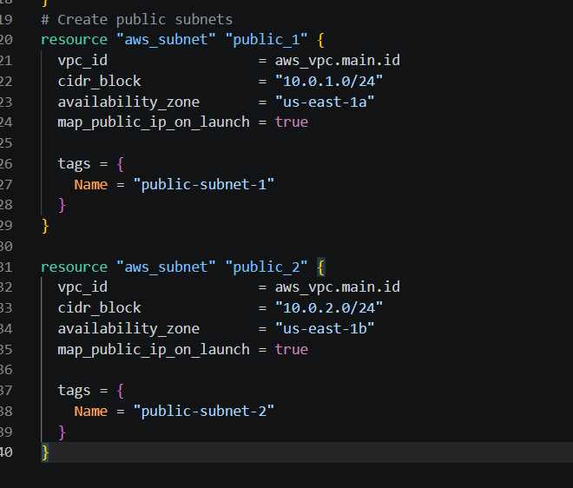
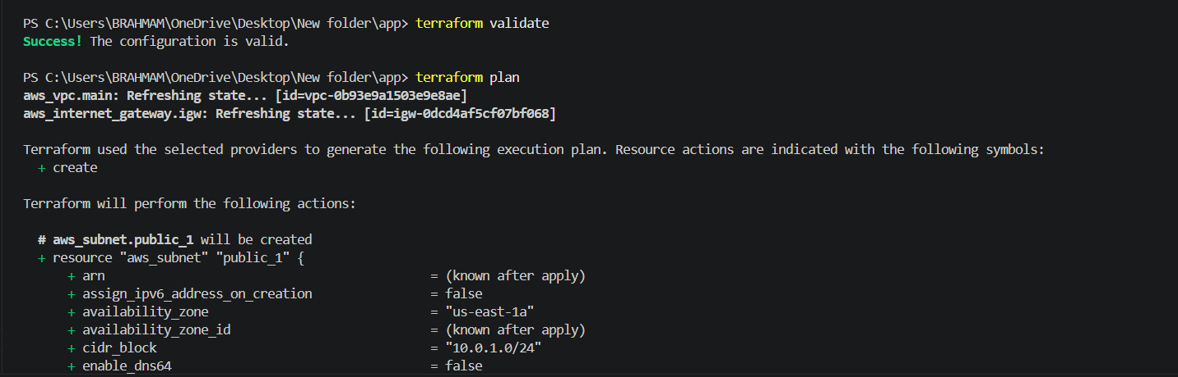

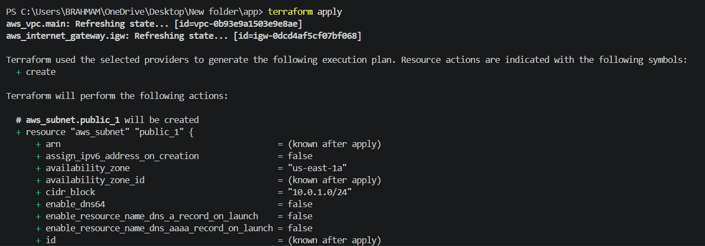
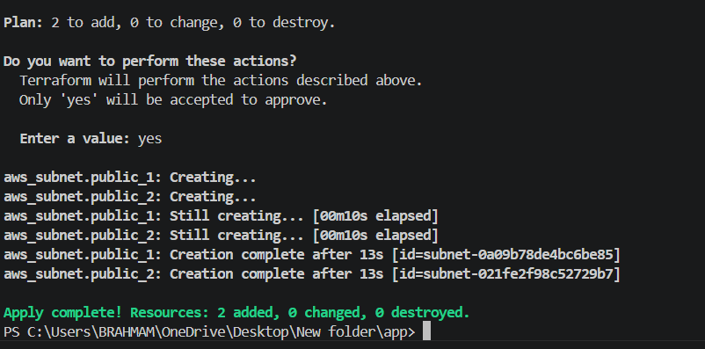
- Two public subnets created successfully
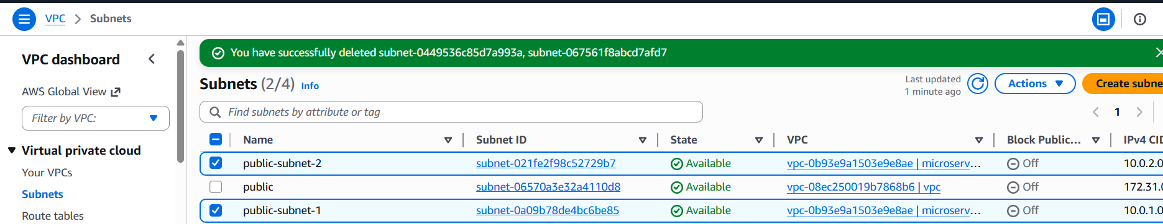
Create Route table and associate route table with both public subnets
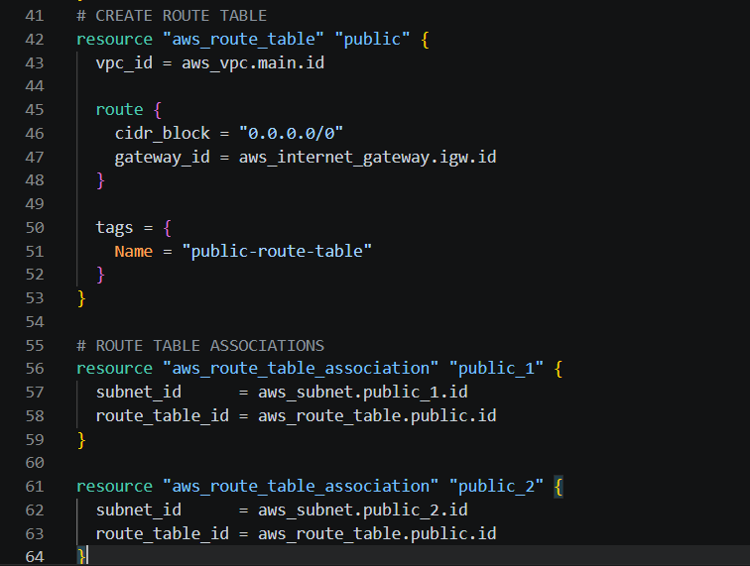
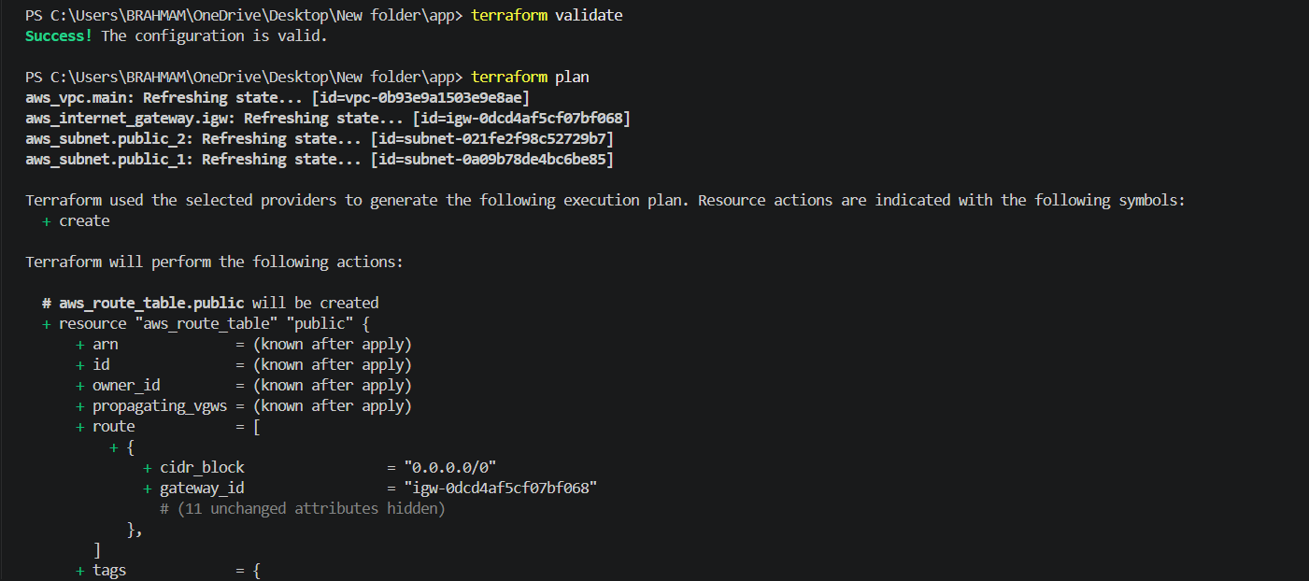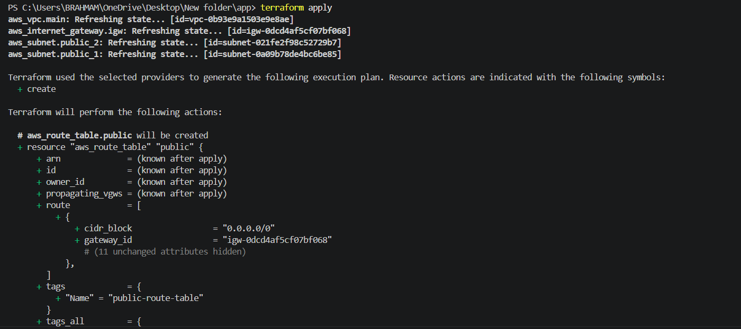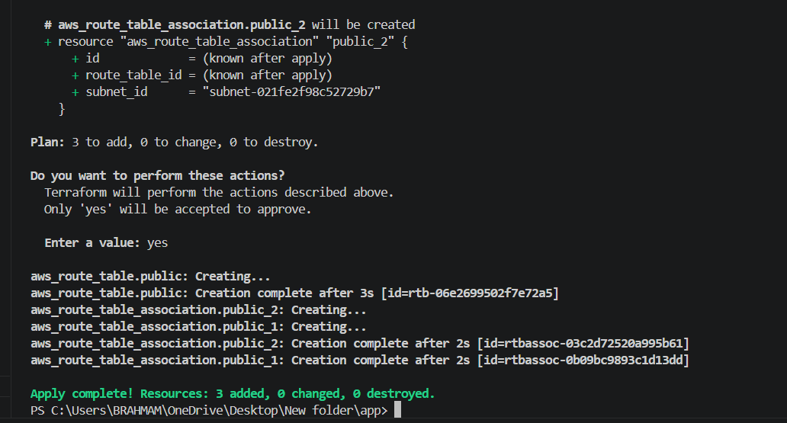
Route tables created and associated successfully
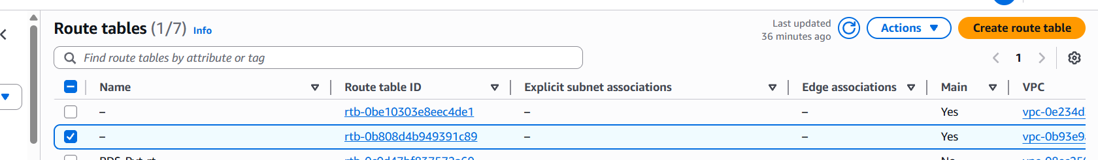What was done:
- Created a dedicated VPC.
- Created two public subnets across diƯerent Availability Zones.
- Configured an Internet Gateway.
- Configured route tables and associations.
Why:
- A dedicated VPC provides isolation from other AWS resources.
- Multiple Availability Zones improve availability.
- ALBs require at least two subnets in diƯerent Availability Zones.
Security Groups
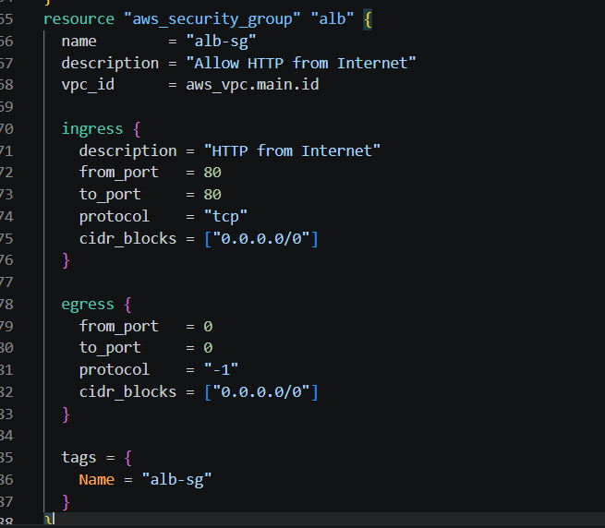
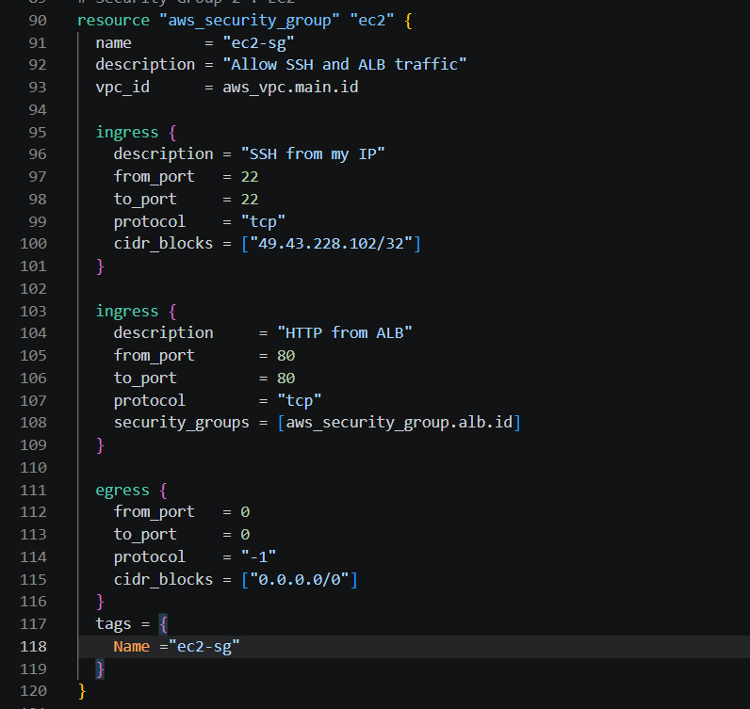
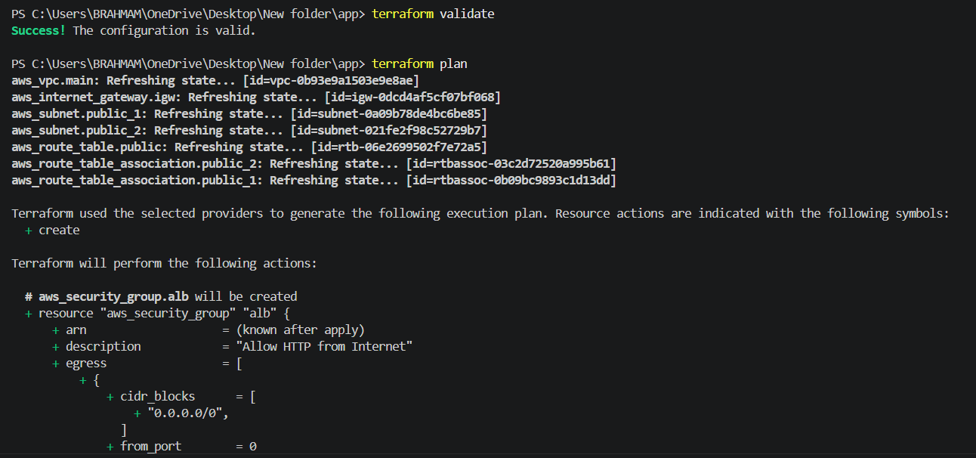
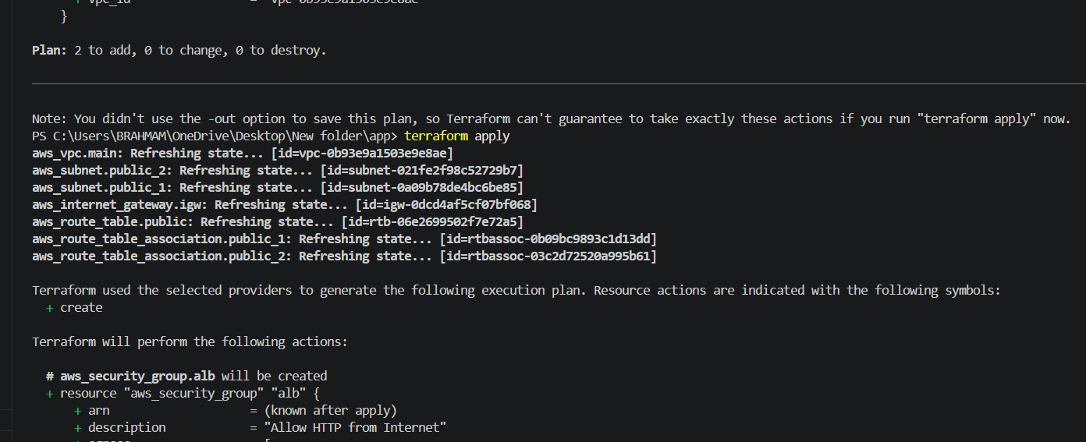
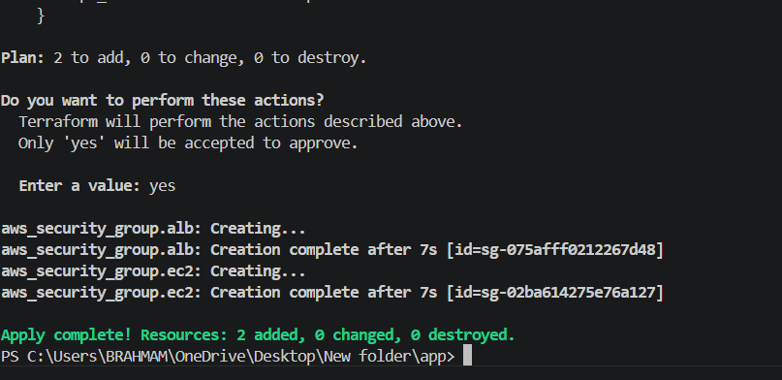
security group created
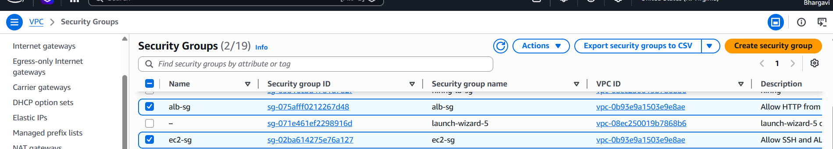
ALB Security Group
- Allows inbound HTTP traffic (port 80) from the internet.
EC2 Security Group
- Allows SSH access only from my public IP.
- Allows HTTP traffic only from the ALB Security Group.
Why:
- This satisfies the requirement that the application should not be directly accessible
- from the internet.
- Restricting SSH access minimizes the attack surface.
- Only the load balancer can communicate with the application.
- Create IAM Role for EC2 and Attach ECR Read Only Policy.

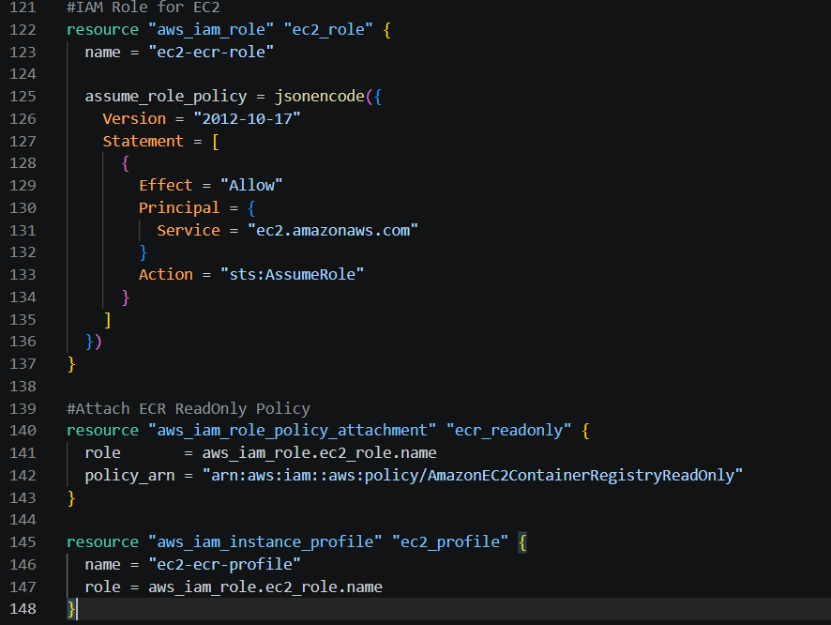
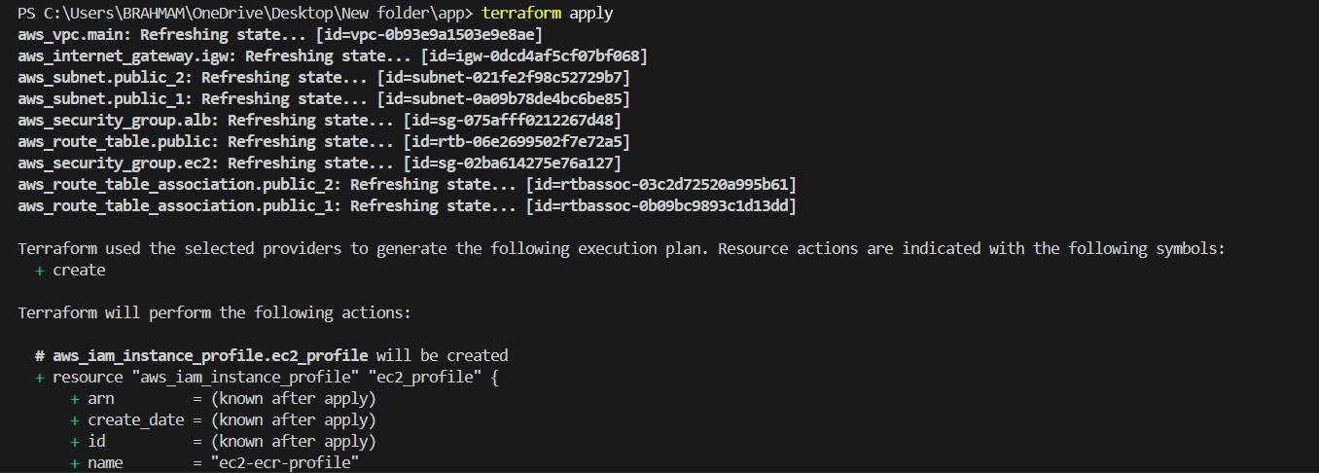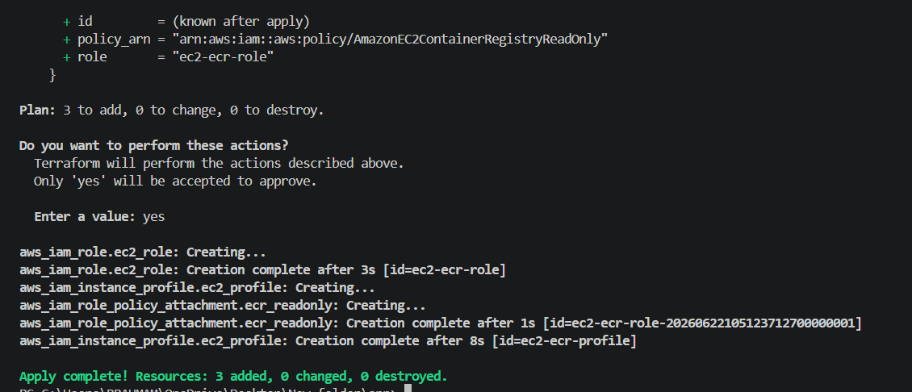
Role created sucesfully added in roles
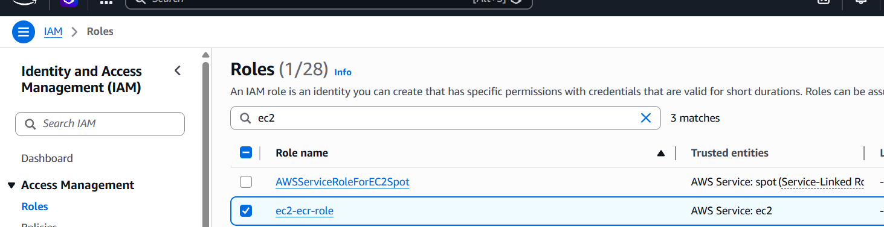We can see that the policy is also attached
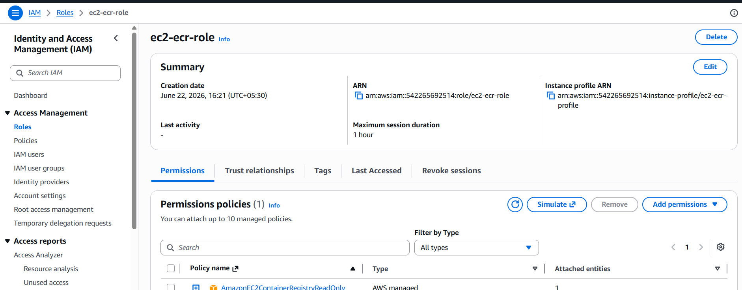
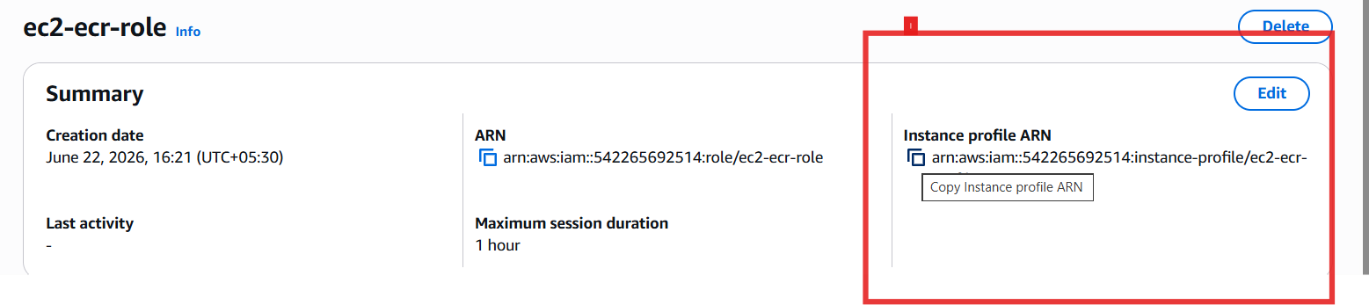
What was done:
- Created an IAM Role for EC2.
- Attached the AmazonEC2ContainerRegistryReadOnly policy.
- Created an Instance Profile and attached it to the EC2 instance.
Why:
- EC2 requires permission to authenticate with ECR.
- Using IAM Roles avoids storing AWS credentials on the instance.
- This follows AWS security best practices.
key pair
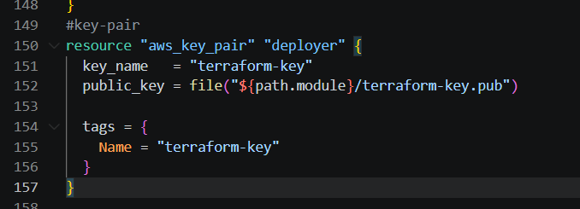
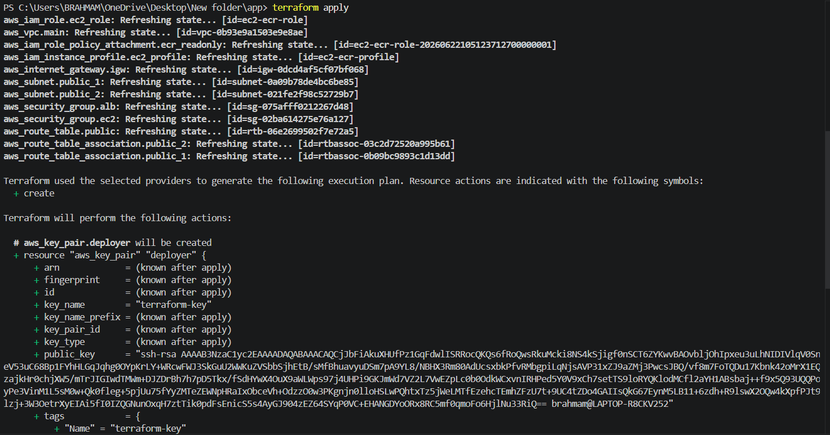
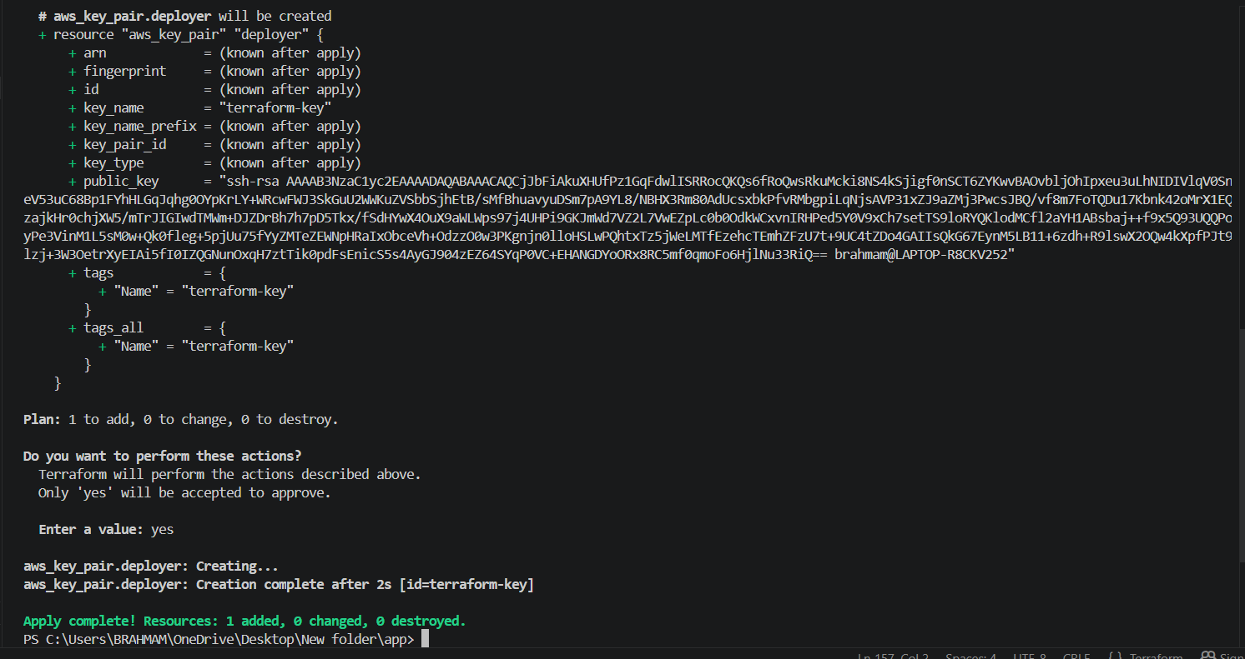
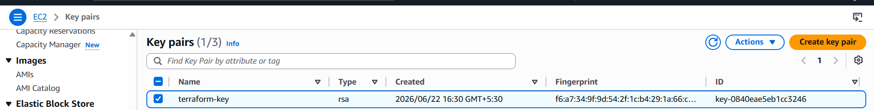
Lets push image to ecrvcreated on ecr--.

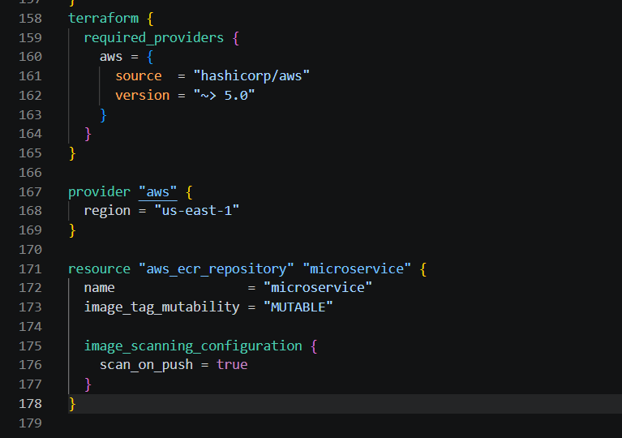
terraform initterraform planterraform apply
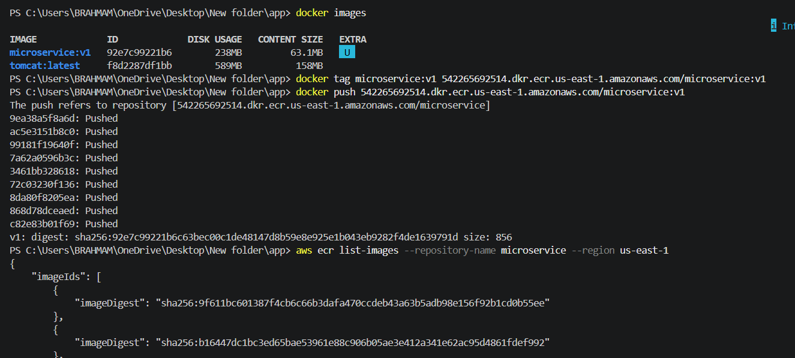
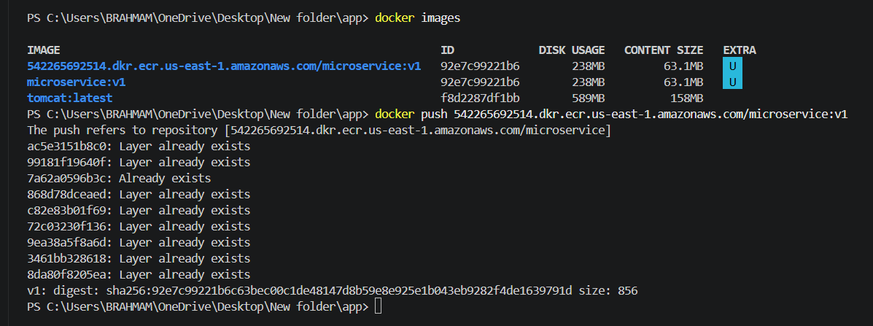
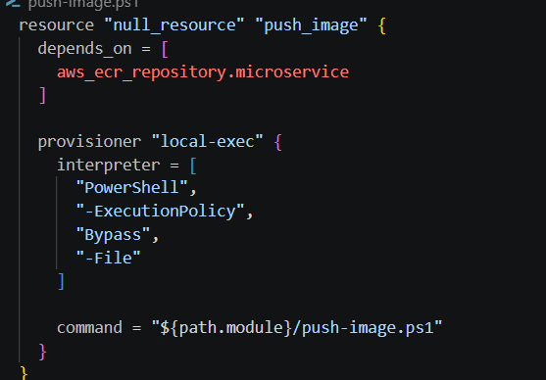
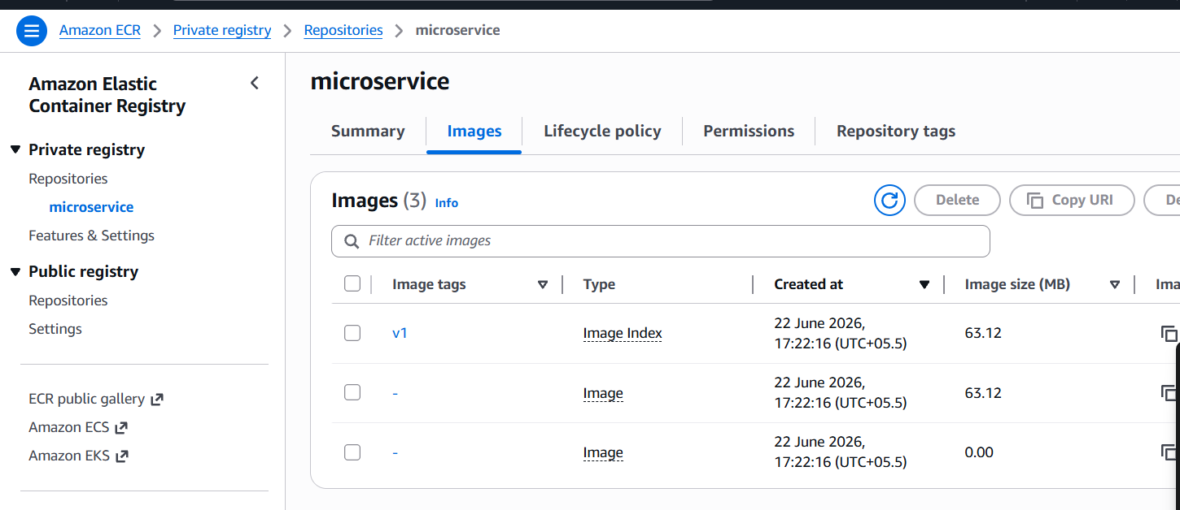
What was done:
- Installed Docker and AWS CLI.
- Started and enabled Docker.
- Logged into ECR.
- Pulled the Docker image.
- Started the container automatically.
Why:
- Automates server configuration during launch.
- Ensures the application is deployed without manual intervention.
- Supports Infrastructure as Code principles.
CREATE EC2 INSTANCE
Configuration
- AMI: ami-0521cb2d60cfbb1a6
- Instance Type: t3.micro
Why:
- t3.micro provides suƯicient resources for a lightweight Nginx container.
- It aligns with free-tier/trial usage considerations.
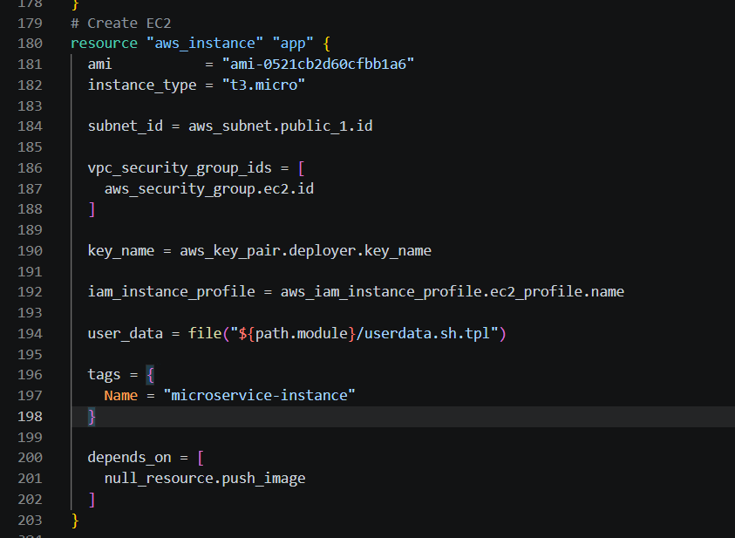
Target Group and Health Checks
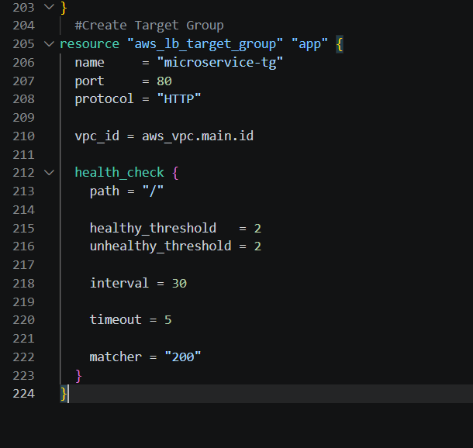
What was done:
- Registered the EC2 instance with a Target Group.
- Configured health checks on /.
Why:
- Health checks ensure that traƯic is only routed to healthy targets.
- Improves reliability and availability.
CREATE APPLICATION LOAD BALANCER
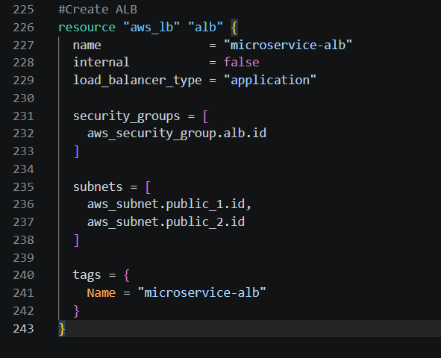
What was done:
- Created an ALB.
- Configured a listener on port 80.
- Forwarded traffic to a Target Group.
Why:
- The challenge explicitly requires that users access the service through a load
- balancer.
- ALB provides health checks and traffic distribution capabilities.

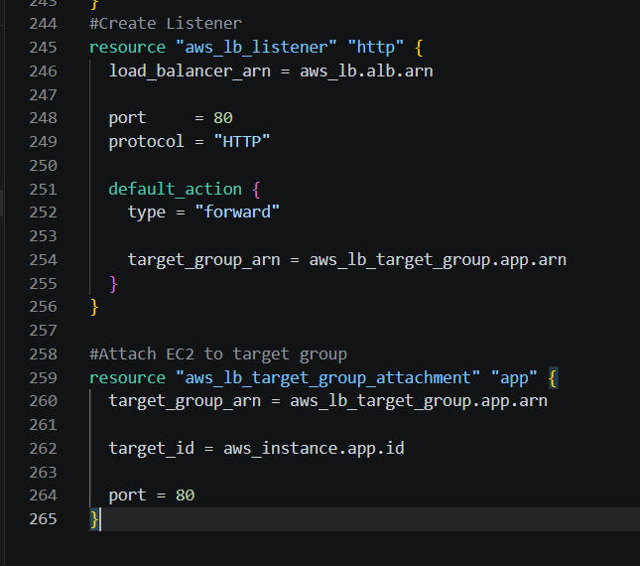
Lets create output.tf
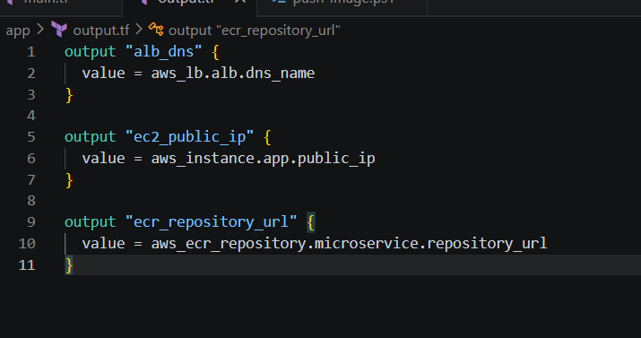
Lets create variables.tf
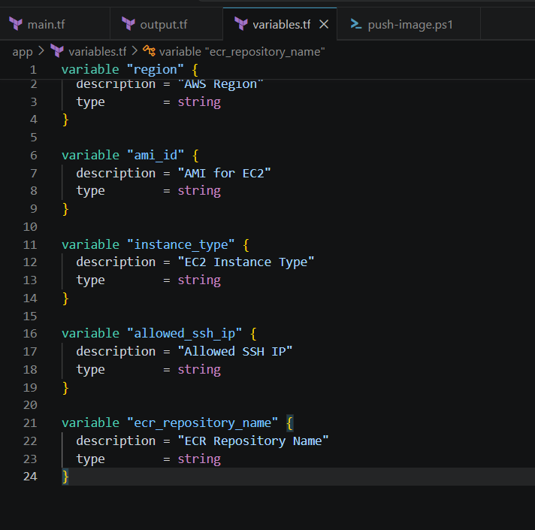
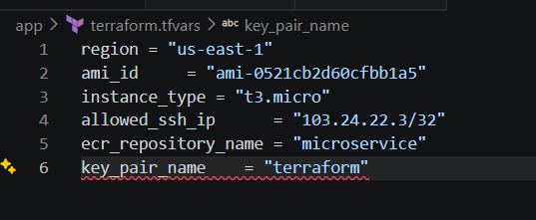
Heare ssh_ip we can take from cmd run as administration
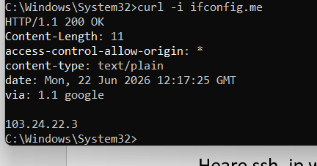
Lets delete all main.tf and put below
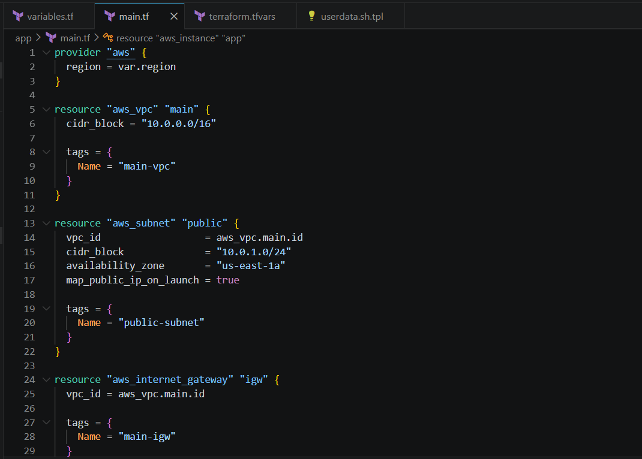
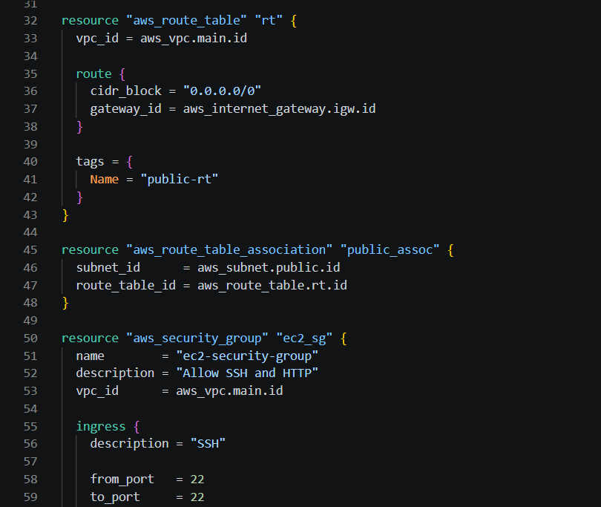
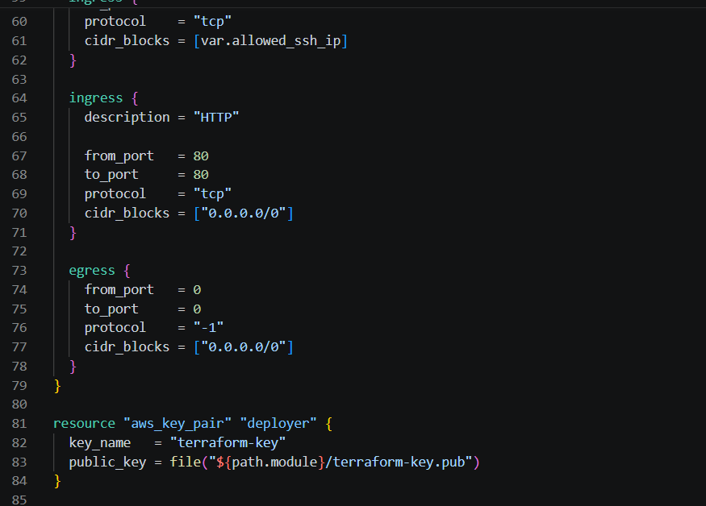
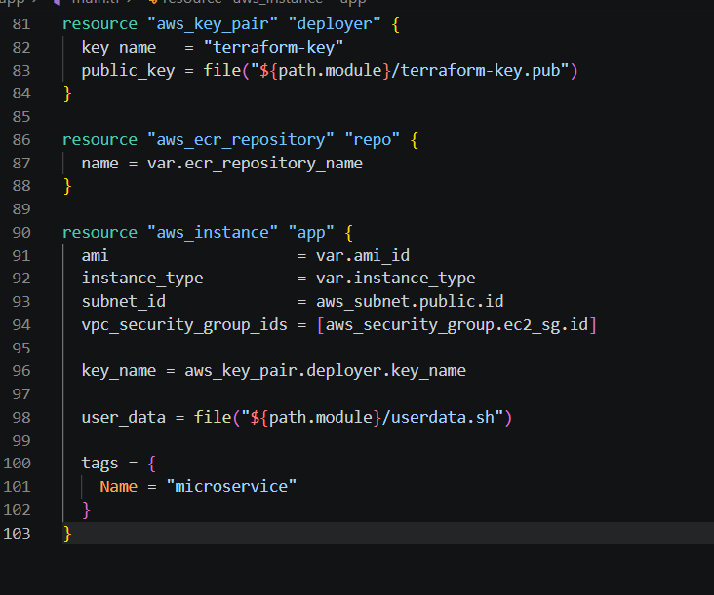
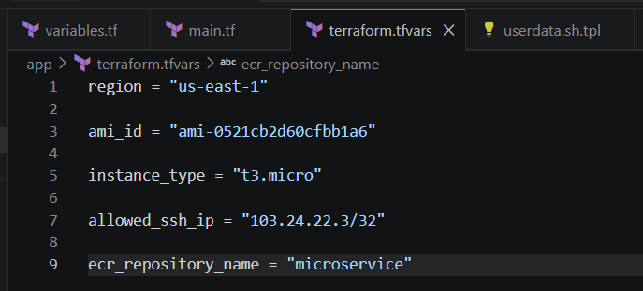
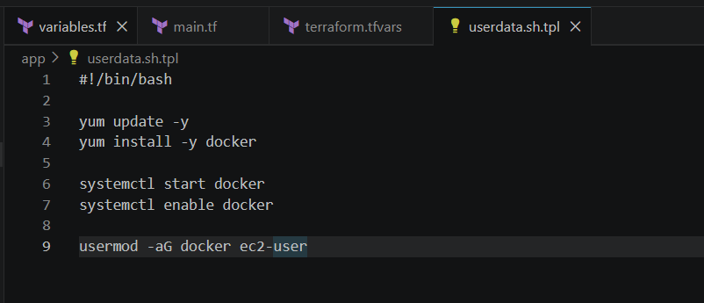
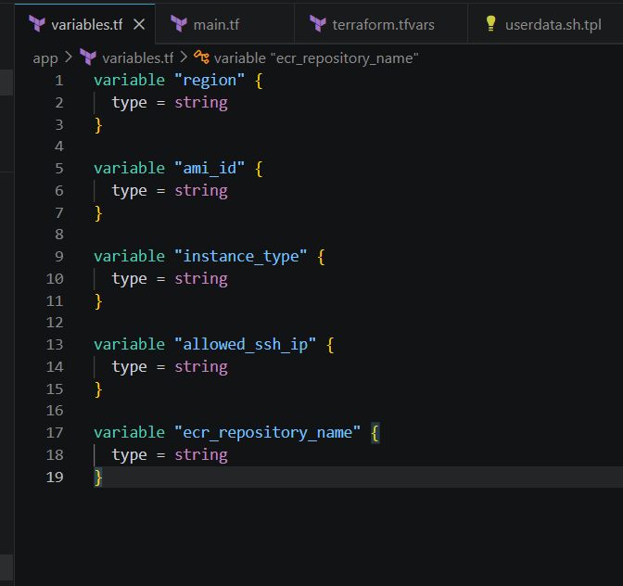
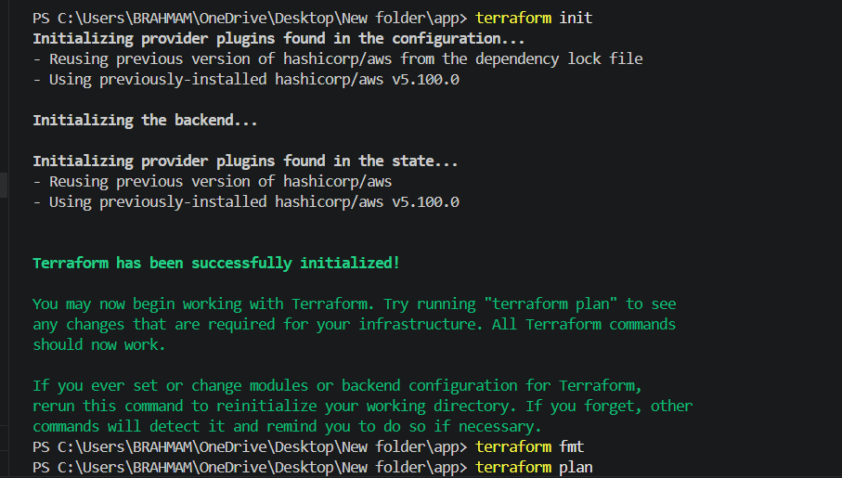
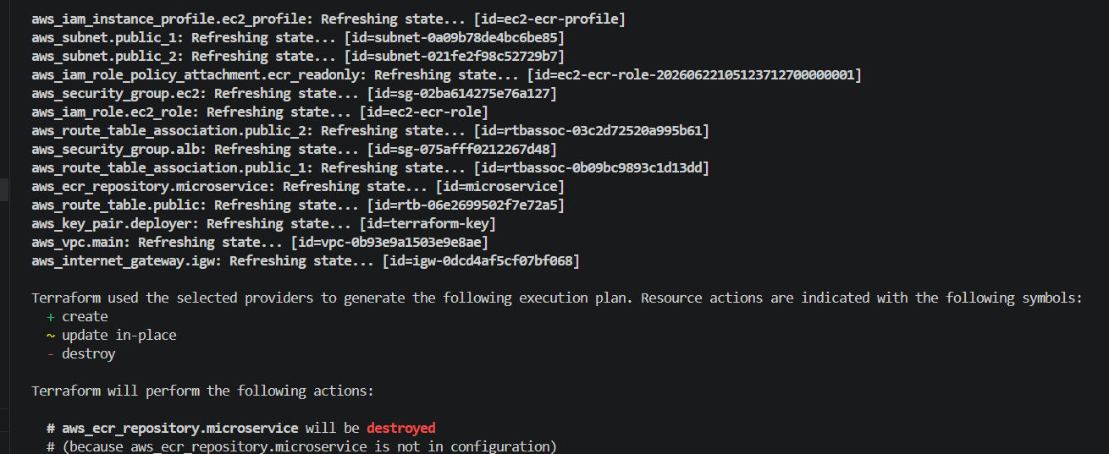
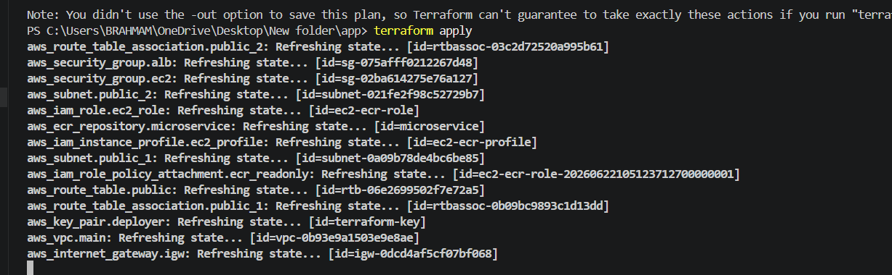
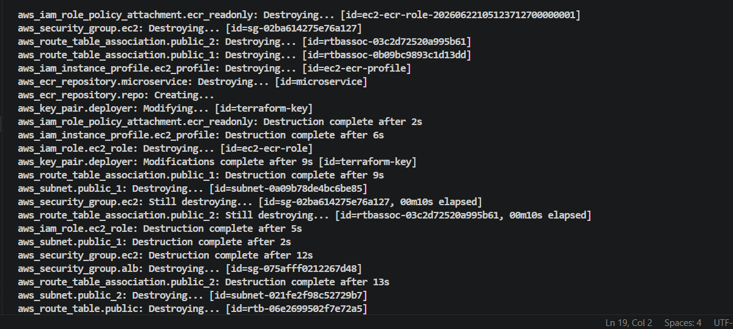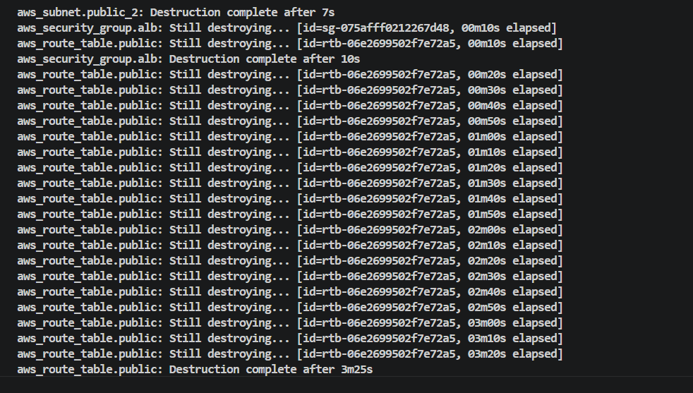
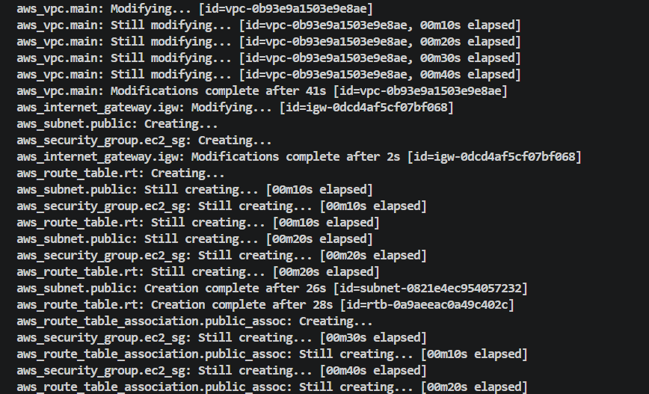
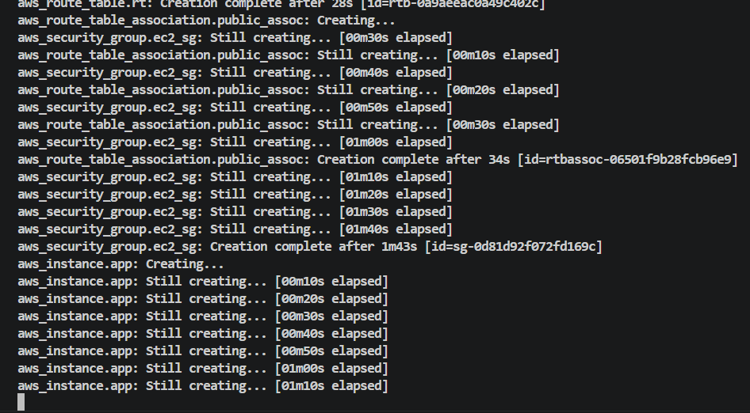
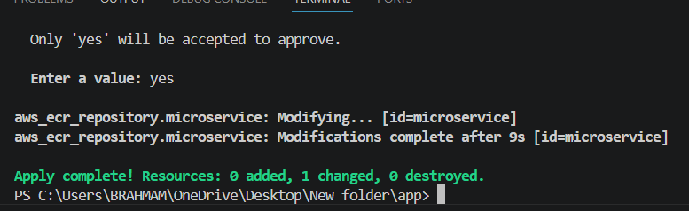
ECS created successfully
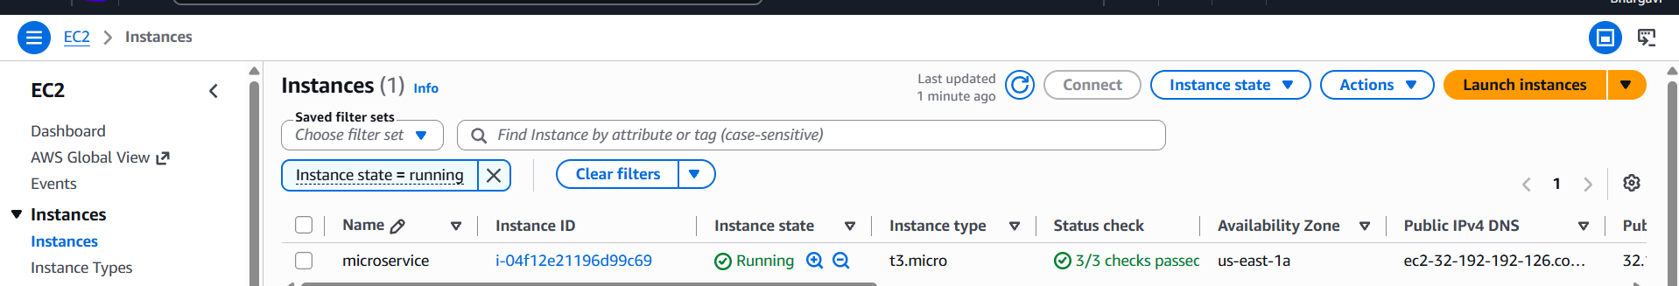
Deployment Flow
1. Build Docker image locally.
2. Create ECR repository.
3. Push Docker image to ECR.
4. Provision networking resources.
5. Provision IAM resources.
6. Launch EC2 instance.
7. Execute bootstrap script via User Data.
8. Pull image from ECR.
9. Start Docker container.
10. Provision ALB and register EC2 target.
11. Access the application using the ALB DNS name.
OUTCOME
The final solution successfully deploys a containerized microservice on AWS using
Terraform while meeting all challenge requirements, emphasizing automation, security,
maintainability, and Infrastructure as Code best practices.

